## Experiment No-10

**Aim:** Write a program to demonstrate find, insert, update and delete operations in MongoDB using NodeJS.

**Code:**

# INSERT:

## insert.js:

var MongoClient = require(‘mongodb’).MongoClient; var url = “mongodb://localhost:27017/”; MongoClient.connect(url, function(err, db) {

if (err) throw err;

var dbo = db.db(“mydb”);

var myobj = { name: “Company Inc”, address: “Highway “ }; dbo.collection(“customers”).insertOne(myobj, function(err, res) { if (err) throw err;

console.log(“1 document inserted”); db.close();

});});

## insert_many.js:

var MongoClient = require(‘mongodb’).MongoClient; var url = “mongodb://localhost:27017/”; MongoClient.connect(url, function(err, db) {

if (err) throw err;

var dbo = db.db(“mydb”); var myobj = [

{ name: ‘John’, address: ‘Highway 71’},

{ name: ‘Peter’, address: ‘Lowstreet 4’},

{ name: ‘Amy’, address: ‘Apple st 652’},

{ name: ‘Hannah’, address: ‘Mountain 21’},

];

dbo.collection(“customers”).insertMany(myobj, function(err, res) { if (err) throw err;

console.log(“Number of documents inserted:” + res.insertedCount); db.close();

});});

# FIND:

find.js

var MongoClient = require(‘mongodb’).MongoClient; var url = “mongodb://localhost:27017/”; MongoClient.connect(url, function(err, db) {

if (err) throw err;

var dbo = db.db(“mydb”);

//Find the first document in the customers collection: dbo.collection(“customers”).findOne({}, function(err, result) { if (err) throw err;

console.log(result.name); db.close();

});});

# UPDATE:

update.js

var MongoClient = require(‘mongodb’).MongoClient; var url = “mongodb://localhost:27017/”; MongoClient.connect(url, function(err, db) {

if (err) throw err;

var dbo = db.db(“mydb”);

var myquery = { address: “Mountain 21” };

var newvalues = { $set: { name: “Hannah”, address: “New address” } }; dbo.collection(“customers”).updateOne(myquery, newvalues, function(err, res) { if (err) throw err;

console.log(“1 document updated”); db.close();

});

# DELETE:

delete.js

var MongoClient = require(‘mongodb’).MongoClient; var url = “mongodb://localhost:27017/”; MongoClient.connect(url, function(err, db) {

if (err) throw err;

var dbo = db.db(“mydb”);

/*Delete the first customers with the address “Mountain 21”*/ var myquery = { address: ‘Highway 71’ };

dbo.collection(“customers”).deleteOne(myquery, function(err, obj) { if (err) throw err;

console.log(“1 document deleted”); db.close();

});

});

## Output:

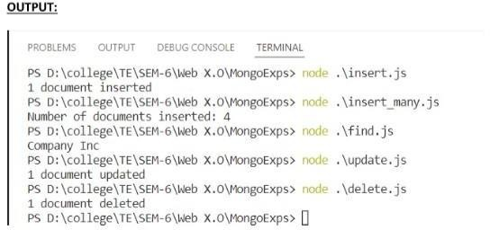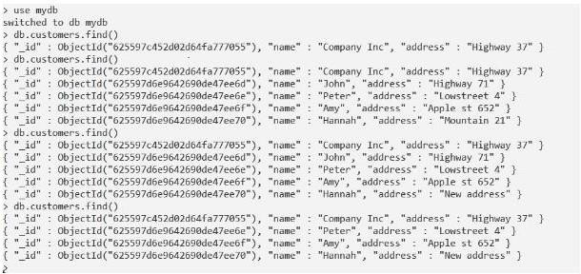

**Conclusion:** Thus, we have created a program to demonstrate find, insert, update and delete operations in MongoDB using NodeJS